Enhancing Image Compression Efficiency using Wavelet Transform: A Comparative Study

Siddharth Dani

*Mathematics & Scientific Computing*

*NIT Hamirpur*

Himachal, India

Siddharthdani75@gmail.com

Shivam Birla

*Mathematics & Scientific Computing*

*NIT Hamirpur*

Himachal, India

Shivambirla139@gmail.com

*Abstract*—This paper first introduces the basic concept, principle and application of wavelet transform. It is a new style mathematic analysis tool which is consider as great breakthrough of tools and method recently. The paper presents selected mathematical methods used for image segmentation and the following segments classification using multiresolution decomposition of segments boundary signals. It involves the applications of wavelet transform across various domains. Focused primarily on image processing, we implemented three distinct MATLAB applications – image fusion, image denoising, and image compression – each leveraging the power of wavelet transforms. Our exploration aimed to harness the versatility of wavelet techniques to enhance the quality, reduce noise, and compress information in digital images.

Keywords- Wavelet Transform, Discrete Wavelet Transform, PNSR, SSIM, Pixel, filter, Denoising.

# Introduction

As outlined earlier, the development of new, transformative methodologies has driven substantial progress in the field of signal processing, and the wavelet transform certainly qualifies as such. Having diverse applications, the goal of the collaborative project was to investigate the ways of the wavelet transform's application and spread. In particular, our team decided to research the area of image processing, with a development to the field of biomedical signal analysis.

Wavelet transforms provide a way to analyze signals at levels of detail enabling the representation of signals, in both frequency and time domains at the time. This versatility makes wavelets highly valuable, in a range of signal processing tasks. Our project focuses on creating three MATLAB applications. Image blending, reducing image noise and compressing images. All utilizing the features of wavelet transforms.

In the image fusion application combining images is done to capture the characteristics of each input image. Meanwhile image denoising works on improving image quality by reducing noise using wavelet thresholding techniques. Furthermore utilizing wavelet compression methods, in image compression demonstrates our capacity to reduce data size without compromising information integrity.

The usual methods used in electronics, information and telecommunications involve analyzing and processing images using discrete transforms. Fourier Sine and Walsh transforms are commonly used in signal processing. Our study aims to explore how wavelet transforms can be applied to signals focusing on ECG and EEG data while leveraging our expertise, in image processing. By harnessing the adaptability of wavelets we aim to offer insights into signal analysis, within the field.

This report, then, showcases which were the methods we are used for our projects, indicates which were the results and finally, shows the importance of what we had discovered. In other words, it may serve as a prescient to show that wavelet transform applications, in signal processing, could be different. It may also be a brief guide for future research.

# literature review

A mathematical method for signal and image processing called the Wavelet transform allows for a multi-resolution analysis that can record both high- and low-frequency components. There are two typical versions of it: the Discrete Wavelet Transform (DWT) and the Continuous Wavelet Transform (CWT). The DWT is more concerned with data compression and noise reduction than the CWT, despite the latter's skill at feature extraction [3]. In this study, we apply the CWT for co-movement analysis in image processing, using the WaveletComp package created by Roesch and Schmidbauer. The discretely sampled wavelets used in the discrete wavelet transform (DWT), developed by mathematician Alfred Haar, make it appropriate for a wide range of signal and picture processing applications [4].

Wavelet decomposition decomposition and subsequently reconstruction offer a multi resolution in signal processing. Issues related to decomposition are well tackled by Mallat , and Nason et al. Reconstruction which is critical in signal synthesis combines the wavelet coefficients with scaling that is lineal. For example, Donoho and Coifman and Donoho effectively discuss reconstruction issues including the effects such as basis selecting wavelet and effects.

In the realm of image fusion, algebraic operations play a crucial role, especially when implementing methods such as Min-Max, Mean, and Max methods. Petrovic and Xydeas (2004) illustrate the algebraic essence of the Min-Max method, where pixel values are selected based on the criteria of either the minimum or maximum values from corresponding wavelet coefficients. Similarly, the Mean method, explored by Liang et al. (1998), involves an algebraic averaging process, combining pixel values to create a composite image.

In image compression, the Haar transform, detailed by Antonini et al. (1992), compresses images through algebraic scaling and differencing operations, yielding coefficients representing various scales and orientations. This process selectively retains coefficients, discarding high-frequency information for significant data reduction while preserving essential image features. Compression ratio directly correlates with the number of retained coefficients. The Haar transform exemplifies an algebraic method for efficiently representing and storing visual information. These techniques, alongside wavelet decomposition and image fusion methods, showcase the mathematical elegance and computational efficacy in signal processing applications. Understanding these principles enhances method implementation and offers insight into their adaptability across diverse domains.

Wavelet-based techniques have demonstrated notable success in image denoising, leveraging their capacity to represent signals in both frequency and time domains. Soft and hard thresholding, pioneered by Donoho and Johnstone (1994), are pivotal components in these algorithms. Further advancements by Coifman and Donoho (1995) and subsequent studies have refined threshold selection methods, optimizing denoising performance. Additionally, techniques such as cycle-spinning, introduced by Mallat and Hwang (1992), have enhanced wavelet transforms' denoising capabilities. Overall, wavelet-based image denoising involves decomposing the image into wavelet coefficients, applying thresholding for noise removal, and reconstructing the denoised image, offering adaptive noise reduction while preserving crucial image details.

# METHODOLOGY

The methodology involves utilizing MATLAB for implementing signal and image processing techniques such as continuous wavelet transform (CWT), and discrete wavelet transform (DWT), Wavelet decomposition, reconstruction, image compression, and denoising, leveraging its built-in functions and toolboxes for efficient implementation.

* 1. *MATLAB*

This research employs wavelet transform (WT) for image processing tasks using the MATLAB environment [5]. MATLAB offers a robust platform for image processing with functionalities well-suited for implementing DWT and analyzing image data.

* 1. Image Data and Preprocessing:

Using the imread function, images will be loaded into the MATLAB workspace. If preprocessing is required, procedures may include scaling with imresize for consistency or converting to grayscale with rgb2gray.

* 1. Discrete Wavelet Transform (DWT):

The Wavelet Toolbox in MATLAB provides powerful tools for DWT. The 2D DWT decomposition will be performed using the **dwt2** function. This function allows us to specify the type of wavelet (e.g., 'haar', 'db4') and the desired number of decomposition levels. For finer control over the decomposition process, we can utilize **wfilters** to obtain the lowpass and highpass filters for a chosen wavelet [6]. These filters can then be applied using **conv2** for a more customized decomposition approach.

* 1. DWT Coefficient Processing:

The DWT coefficients obtained after decomposition will be processed based on the specific application. For image compression, detail coefficients at higher decomposition levels might be thresholded using appropriate thresholding functions from MATLAB to discard less significant information [11]. Noise reduction might involve thresholding or utilizing shrinkage functions available in the Wavelet Toolbox to remove noise from the coefficients.

* 1. Image Reconstruction:

The modified DWT coefficients will be used to reconstruct the processed image. MATLAB's **idwt2** function performs the inverse DWT, yielding the final processed image.

* 1. Performance Evaluation:

Within the MATLAB environment, the efficacy of the WT-based image processing technique will be assessed. The quality of the original and processed images can be compared using built-in tools like ssim (Structural Similarity Index Measure) and psnr (Peak Signal-to-Noise Ratio) [7]. The picture Processing Toolbox's functions can be used to calculate pertinent features from the processed picture data for applications like feature extraction.

1. *Continuous Wavelet Transform*

The continuous wavelet transform of a function x (t) at a scale ( a > 0, a∈R+) and translational value b∈R is shown by a formula:

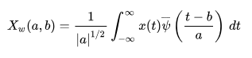

Here:

* a is the scale parameter,
* b is the translation parameter,
* ψ∗(t) is the complex conjugate of the wavelet function,
* CWTx(a,b) gives the coefficient at scale a and b.

1. *Discrete Wavelet Transform*

The Haar wavelet transform can be used to pair together input values in order to save the difference and pass the sum, assuming that the input is represented by n numbers [2,3]. Recursively repeating the operation yields a final sum and 2n − 1 differences . Consequently, the formulas can be modified to the following:

C:\Users\hg799\OneDrive\Pictures\Screenshots\Screenshot (101).png

where

k = 0, 1, …, 2j − 1 and j = 0, 1, …, log2N – 1

1. *Wavelet Image Fusion*
   1. Representation of Wavelet Coefficients:

Define (C_1) and (C_2) as the wavelet coefficients of two input images.

* 1. Min-Max Fusion Operation:

Identify the algebraic operation for Min-Max fusion:

Select the minimum or maximum of (C_1) and (C_2) for each corresponding coefficient.

* 1. Mean Fusion Operation:

Define the algebraic operation for Mean fusion:

Calculate the average of (C_1) and (C_2) for each corresponding coefficient using the formula

((C_1 + C_2) / 2).

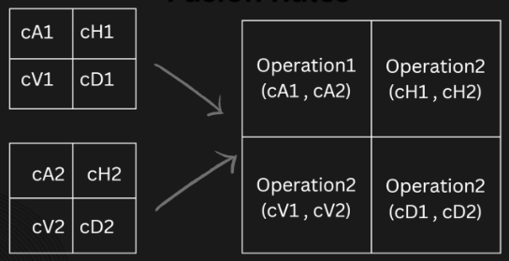

1. *Wavelet Decomposition and Reconstruction*

The design involves decomposing an original image into wavelet coefficients using `dwt2`, applying matrix operations for coefficient calculations, and reconstructing the image using `idwt2`.

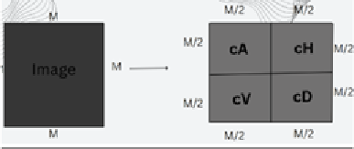

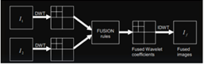

1. *Image Compression*

The design involves applying the Haar Wavelet Transform to the image, followed by thresholding the wavelet coefficients to achieve compression [8]. The Inverse Haar Transform is then used to reconstruct the compressed image.

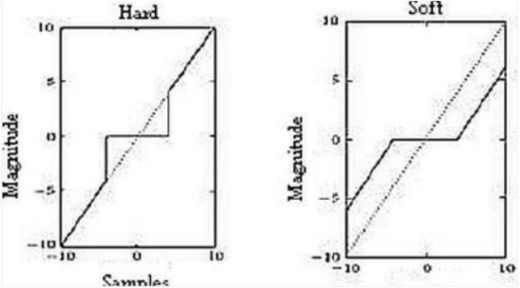

1. *Image Denoising*

The design involves decomposing the noisy image using wavelet decomposition, applying soft and hard thresholding to the wavelet coefficients, and reconstructing the denoised image

1. Decomposition:

DWT(Inoisy)={C1,C2,…,Cn}

1. Soft Thresholding:

Sλ(x)=sign(x)⋅(∣x∣−λ)+

1. Hard Thresholding:

Hλ(x) = x , if ∣x∣≥λ ,

0, otherwise

1. Reconstruction:

Idenoised-soft= IDWT(Sλ(C1),Sλ(C2),…,Sλ(Cn))

Idenoised-hard= IDWT(Hλ(C1),Hλ(C2),…,Hλ(Cn))

# Result

*MATLAB Wavelet Transformation*

As can be seen below, the original image below will be broken down into its approximate average component, horizontal component, vertical component, and diagonal component.

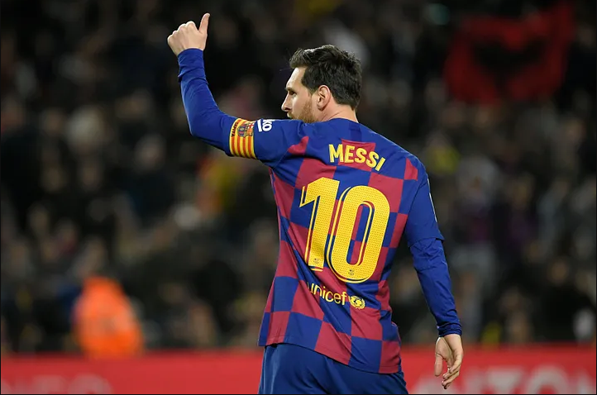

*Orignal Image before Transformation*

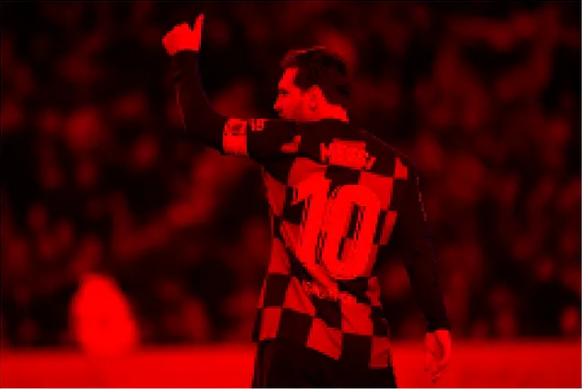

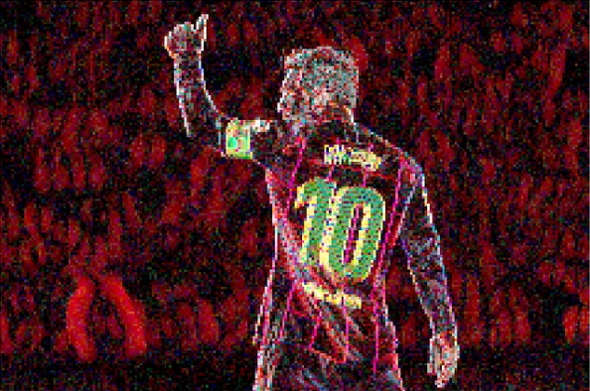

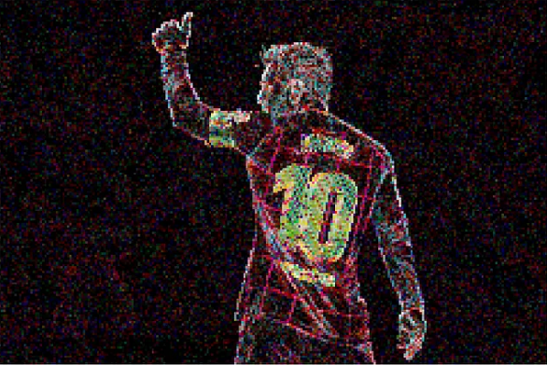

*Decomposition of Image into sub-signals*

*Wavelet-based Image Denoising*

In signal processing, wavelet transform is a commonly used method for denoising and compression [9]. After completing wavelet decomposition, we will use global thresholding in the image's frequency distribution to denoise any gaussian noise that may be present. In essence, this removes noise in the frequency domain by acting as a filter.

We apply a three-level discrete wavelet transform to a noisy picture, followed by high frequency (detail) component thresholding in the image's frequency domain.

First, we calculate each detail coefficient's threshold. We obtain the denoised matrices for each level's detail components after applying the threshold to every level. To recreate the image, we employ these matrices as coefficients for an inverse discrete wavelet transformation. The image that was rebuilt has been denoised [10].

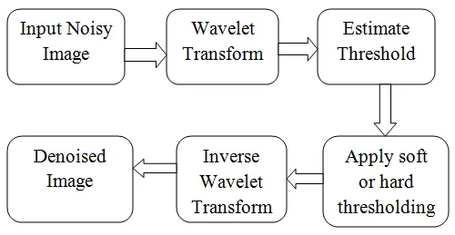

*Block Diagram of Wavelet Denoising Technique*

*The pictures below illustrate how hard-thresholding works.*

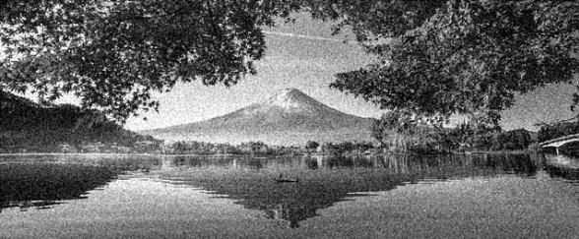

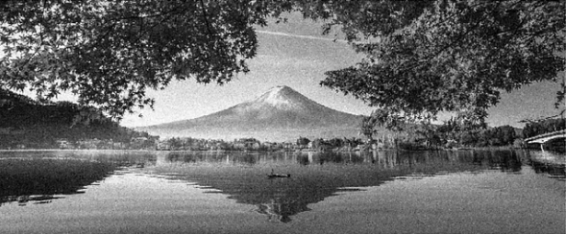

*Before and after denoising using hard-thresholding*

*Wavelet-based Image Compression*

One type of data compression that works well for compressing images is wavelet compression. The goal is to use the least amount of file space feasible to hold picture data [12]. Either lossless or lossy wavelet compression is possible.

In this section, we'll compress photos using wavelet decomposition. After completing a 4-level decomposition, we apply thresholding to detail components. To do this, the wavelet coefficients are sorted, the greatest 20%, 10%, 1%, and 0.5% of the coefficients are kept, and the remaining coefficients are thresholded to zero.

the application of a 4-level wavelet decomposition in MATLAB for image compression. The built-in functions wavedec2() and waverec2(), which disassemble and rebuild images to and from sub-signals, make this task simple [13].

The effect of various values of thresholding can be observed below.

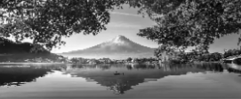

*20%*

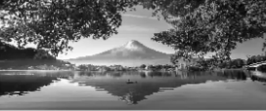

*10%*

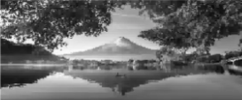

*1%*

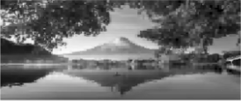

*0.5%*

*Effect of different threshold values on compression*

This essentially functions as a frequency domain filter (low-pass, high-pass, band-pass, etc.), which is typically employed in fourier transformations, as we are just keeping a set of coefficients at each level [14]. Since we're working with wavelets, wavelet compression is an improved version of fourier compression.

# CONCLUSION

To sum up, our exploration of wavelet-based image processing has revealed a flexible toolkit that can be used to tackle a variety of problems in the field of signal and image analysis. We have seen the results of picture fusion, compression, denoising, and decomposition techniques. wavelet transforms' flexibility to many activities and situations.

The findings highlight the careful balancing act that needs to be done when choosing parameters, highlighting the complex interactions between fusion techniques, denoising schemes, and compression levels. With an approachable framework for modification and experimentation, the MATLAB implementations have offered a useful link between theoretical foundations and practical applications.

Upon considering the constraints and prospects, it is apparent that the investigation of wavelet-based methodologies surpasses the purview of this research project. Prospective research paths entice us to investigate the intricacies of color picture processing, investigate innovative wavelet kinds, and use these techniques into cutting-edge innovations such as deep learning systems.

To put it briefly, our investigation into wavelet-based image processing is evidence of the methods' continuing applicability and durability in the dynamic field of signal and image analysis. The innovative fabric weaved from mathematical ideas and real-world applications We are filled with wonder and excitement about the unrealized possibilities that lies ahead after implementations. Wavelets continue to influence the field of image processing with their complex patterns and transformational powers. They provide a vibrant canvas on which scholars and industry professionals can paint the next chapters of exploration and invention.

# REFERENCES

1. Batchelor, B. G., "sequency theory": foundations and applications. Journal of Sound and Vibration, 58(4), 607-607, (1978).
2. Mallat, S. G., A theory for multiresolution signal decomposition: the wavelet representation. IEEE Transactions on Pattern Analysis & Machine Intelligence, 11(4), (1989).
3. Shensa, & M., J., The discrete wavelet transform: wedding the a trous and mallat algorithms. Signal Processing, (1992).
4. Rioul, O. & Duhamel, P., Fast algorithms for discrete and continuous wavelet transforms. Information Theory IEEE Transactions on, 38(2), 569-586, (1992).
5. Daubechies, I., Ten Lectures on Wavelets, SIAM, (1992).
6. Mallat, S., A Wavelet Tour of Signal Processing: The Sparse Way, Academic Press, (2008).
7. Strang, G., & Nguyen, T., Wavelets and Filter Banks, Wellesley-Cambridge Press, (1996).
8. Burrus, C. S., Gopinath, R. A., & Guo, H., Introduction to Wavelets and Wavelet Transforms: A Primer, Prentice Hall, (1997).
9. Mallat, S. G., A theory for multiresolution signal decomposition: The wavelet Representation. IEEE Transactions on Pattern Analysis and Machine Intelligence, 11(7), 674-693, (1989).
10. Nason, G. P., & von Sachs, R., Wavelet processes and adaptive estimation of the Evolutionary wavelet spectrum. Journal of the Royal Statistical Society: Series B (Statistical Methodology), 61(2), 271-292, (1999).
11. Gonzales, R. C., & Woods, R. E., Digital Image Processing, Pearson Education, (2008).
12. Van De Ville, D., & Unser, M., The Continuous Wavelet Transform: Construction and Properties. In A. Aldroubi, M. Unser (Eds.), Wavelets in Medicine and Biology (pp. 19-61), CRC Press, (2009).
13. Mallat, S., & Hwang, W. L., Singularity detection and processing with wavelets. IEEE Transactions on Information Theory, 38(2), 617-643, (1992).
14. Coifman, R. R., & Donoho, D. L., Translation-Invariant De-Noising. In Wavelets and Statistics (pp. 125-150), Springer, (1995).